**SkyAirlines Flight Booking Application**

A MERN Stack Project

Submitted By:

SURENDAR E

7th Semester, Computer Science Engineering

Date:

Abstract

**SkyAirlines** is a modern flight booking web application designed to simplify the process of searching and booking flights for users. Developed using the MERN stack (MongoDB, Express.js, React.js, Node.js), this project incorporates responsive design, advanced flight filtering, and user authentication via Google and Facebook. The platform offers a visual seat selection feature to enhance user experience, alongside a robust backend for seamless API interactions. The project demonstrates the integration of full-stack technologies to create a real-world, scalable solution.

Introduction

Problem Statement:  
Traditional methods of flight booking can be time-consuming and lack modern functionalities like advanced filtering and seat selection.

Objective:  
The aim of this project is to build a user-friendly, responsive flight booking web application that enhances user experience with features like intuitive search, visual seat selection, and secure user authentication.

Scope:  
The application is designed for desktop and mobile users, offering a smooth and consistent experience across platforms.

Technical Details

Frontend:

* Framework: React.js
* Styling Libraries: Material-UI, Bootstrap
* Features: Responsive design, React hooks for state management

Backend:

* Framework: Node.js and Express.js
* APIs: RESTful APIs for data handling and user interactions

Database:

* Database: MongoDB Atlas
* Object-Document Mapper (ODM): Mongoose

Tools Used:

* Postman: API testing
* GitHub: Version control

Features

1. Flight Search:
   * Allows users to search flights by specifying origin, destination, and travel dates.
   * Filters for price, airline, and time range.
2. Visual Seat Selection:
   * Interactive interface to select seats graphically.
   * Ensures real-time availability status.
3. User Authentication:
   * Login and signup options using email, Google, and Facebook accounts.
4. Responsive Design:
   * Optimized for mobile, tablet, and desktop devices.
5. User-Friendly Interface:
   * Simple navigation and modern UI/UX design.

Implementation

Frontend:  
The frontend is implemented using React.js with components organized into a structured file hierarchy:

* Components Folder:
  + Header.jsx: Navigation bar with links to Login and Signup.
  + FlightSearch.jsx: Handles flight search queries.
  + FlightList.jsx: Displays search results dynamically.
  + SeatSelection.jsx: Interactive seat booking.
  + Footer.jsx: Contains app credits and contact information.
* Styling:
  + Used Material-UI for consistent and professional UI components.
  + Bootstrap’s grid system ensured responsive layouts.

Backend:  
The backend is powered by Node.js and Express.js.

* Key Endpoints:
  + /api/flights: Fetches flight data based on user queries.
  + /api/users: Handles user registration and authentication.
* Database Design:
  + Users Collection: Stores user details and authentication tokens.
  + Flights Collection: Stores flight details such as origin, destination, and pricing.

Challenges and Solutions

1. Challenge: Synchronizing the frontend and backend for real-time data display.
   * Solution: Debugged RESTful APIs and implemented efficient data handling in Express.js.
2. Challenge: Making the application responsive.
   * Solution: Leveraged Material-UI’s grid system and extensively tested layouts on different devices.

Results and Screenshots

Homepage:

Displays flight search options.

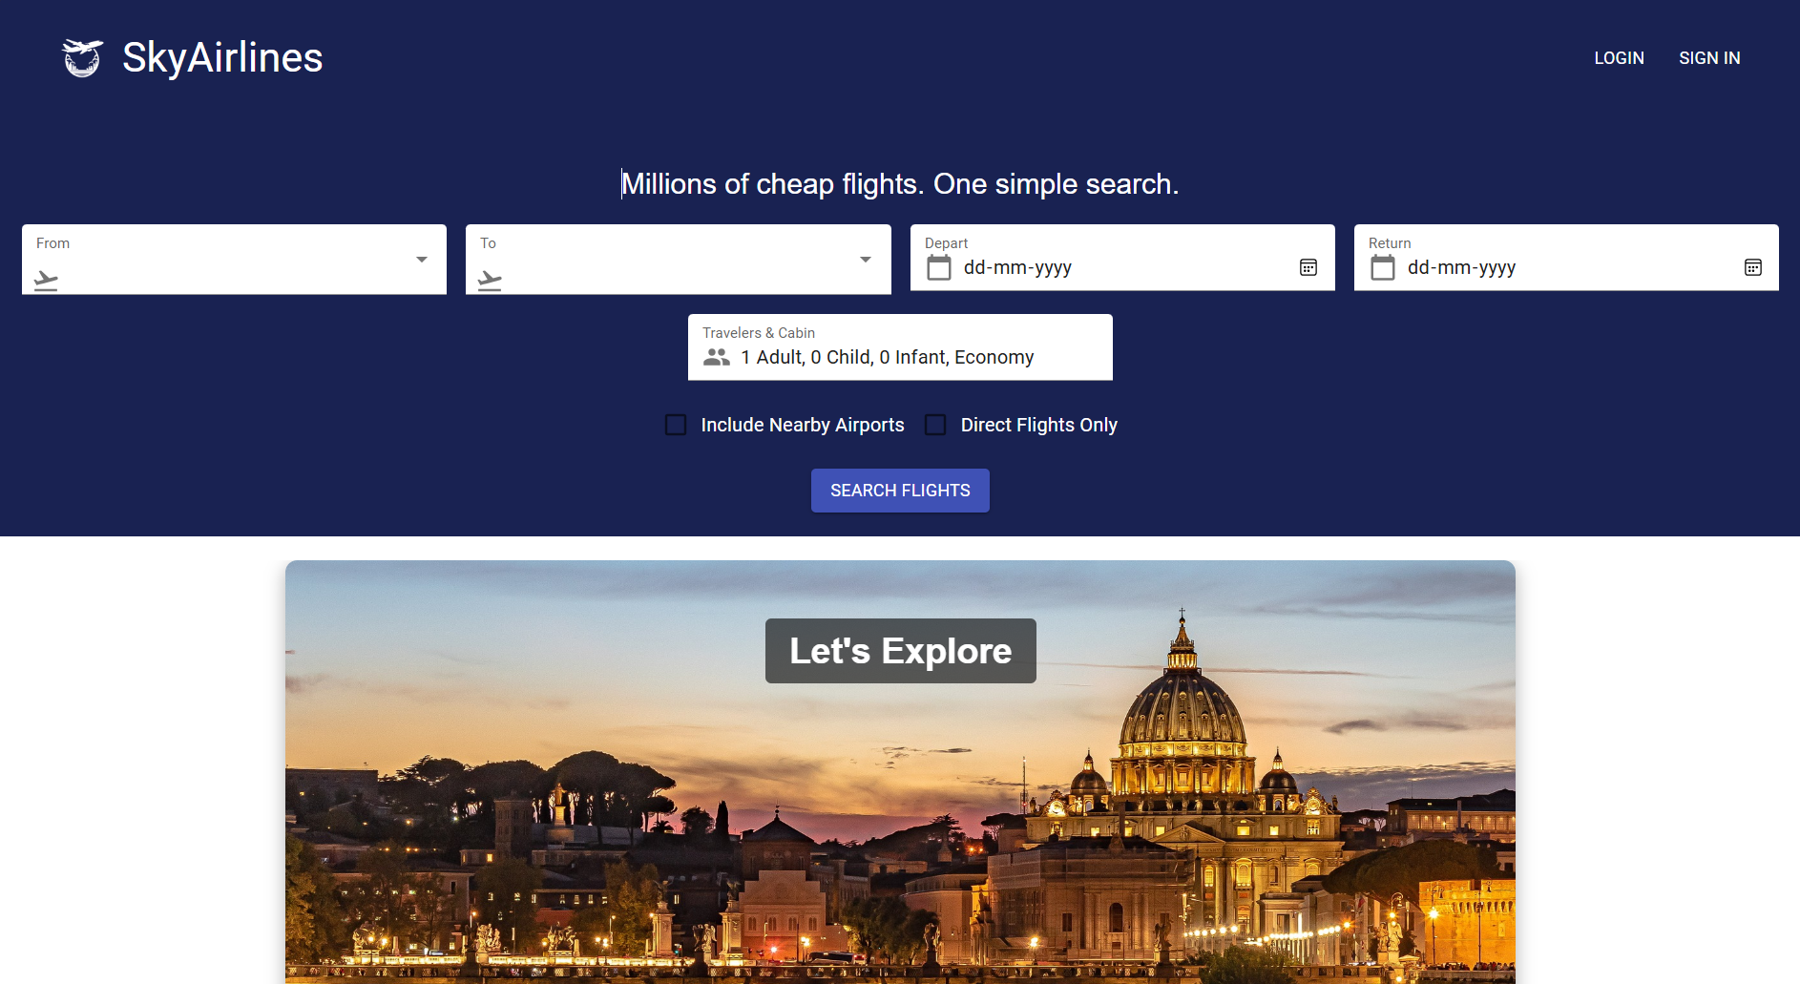

Search Results:

Shows available flights with filters for sorting.

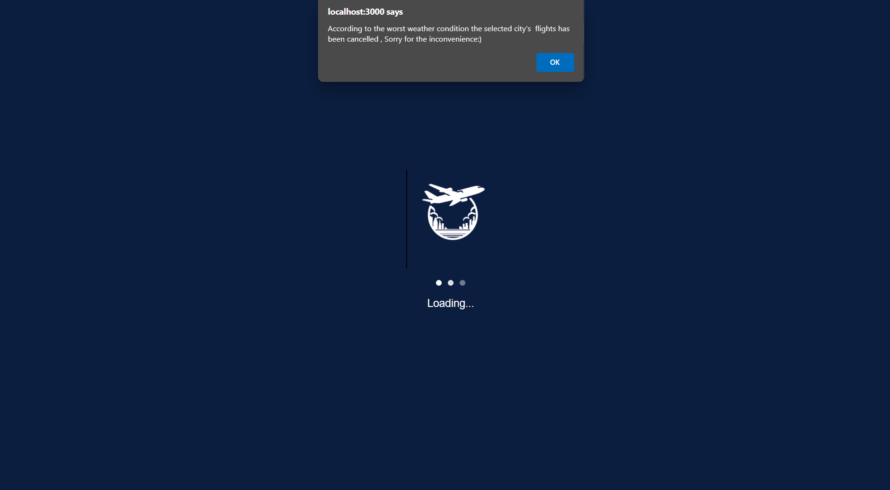

Seat Selection:

Interactive graphical seat map.

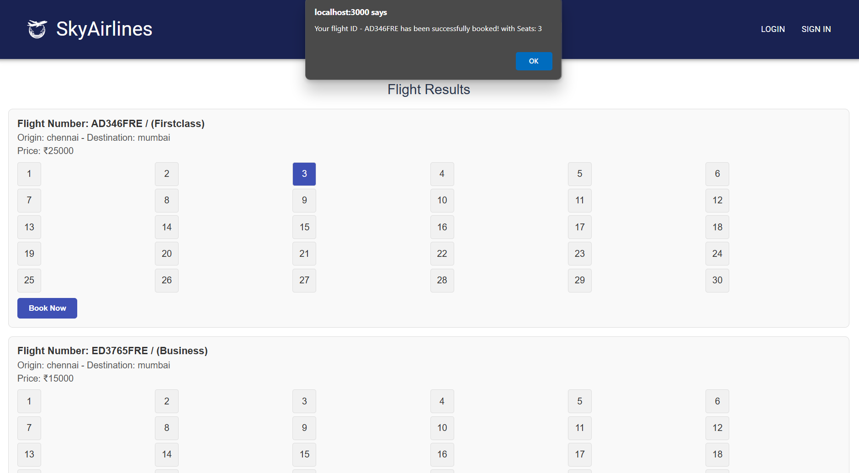

Testing and Validation

Frontend Testing:

Manually validated functionality on Chrome and mobile browsers.

Backend Testing:

Used Postman to test API responses for various scenarios.

Database Validation:

Verified MongoDB collections to ensure data integrity.

Conclusion and Future Scope

Conclusion:

The project demonstrates the practical application of the MERN stack for building a functional web application. Key takeaways include gaining proficiency in API integration, MongoDB, and responsive design.

Future Scope:

* Integration of payment gateways.
* AI-based dynamic pricing recommendations.
* A user dashboard for travel history and loyalty points.

References

1. React.js Official Documentation
2. MongoDB Atlas Documentation
3. Material-UI Library
4. Tutorials on RESTful API Design
5. Skyscanner Website

THANK YOU